**B_18_DAYAL ADITYA KISHOR**

**Assignment No. 6**

**Title:**

Study and Implementation of

* Group By & having clause
* Order by clause
* Indexing

**Problem Statement:**

Create tables in ORACLE using SQL DDL statements  
Sailor(sid:integer, sname:string, rating:integer, age:real)  
Boat(bid:integer, bname:string, color:integer)  
Reserves(sid:integer, bid:integer, day:date)

1. Insert following records in the above tables  
   Sailors

|  |  |  |  |
| --- | --- | --- | --- |
| sid | sname | rating | age |
| 22 | Dustin | 7 | 45.0 |
| 29 | Brutus | 1 | 33.0 |
| 31 | Lubber | 8 | 55.5 |
| 32 | Andy | 8 | 25.5 |
| 58 | Rusty | 10 | 35.0 |
| 64 | Horatio | 7 | 35.0 |
| 71 | Zorba | 10 | 16.0 |
| 74 | Horatio | 9 | 35.0 |
| 85 | Art | 3 | 25.5 |
| 95 | Bob | 3 | 63.5 |

Boat

|  |  |  |
| --- | --- | --- |
| bid | bname | color |
| 101 | Interlake | Blue |
| 102 | Interlake | Red |
| 103 | Clipper | green |
| 104 | Marine | red |

Reserves

|  |  |  |
| --- | --- | --- |
| sid | bid | day |
| 22 | 101 | 10/10/98 |
| 22 | 102 | 10/10/98 |
| 22 | 103 | 10/8/98 |
| 22 | 104 | 10/7/98 |
| 31 | 102 | 11/10/98 |
| 31 | 103 | 11/6/98 |
| 31 | 104 | 12/12/98 |
| 64 | 101 | 9/5/98 |
| 64 | 102 | 9/8/98 |
| 74 | 103 | 9/8/98 |

1. Find the age of the oldest sailor for each rating level. Print the rating level also
2. Find the average age of sailors for each rating level that has at least two sailors
3. Find the number of reservations of each boat order by boat id.
4. Find the age of the youngest sailor who is eligible to vote(i.e. at least 18 years old) for each rating level.
5. Create index on sid column for sailors table

**Answer:**

Create Tables Sailor, Boat, Reserves

create table Sailor (sid int primary key, sname varchar(20), rating int, age real);

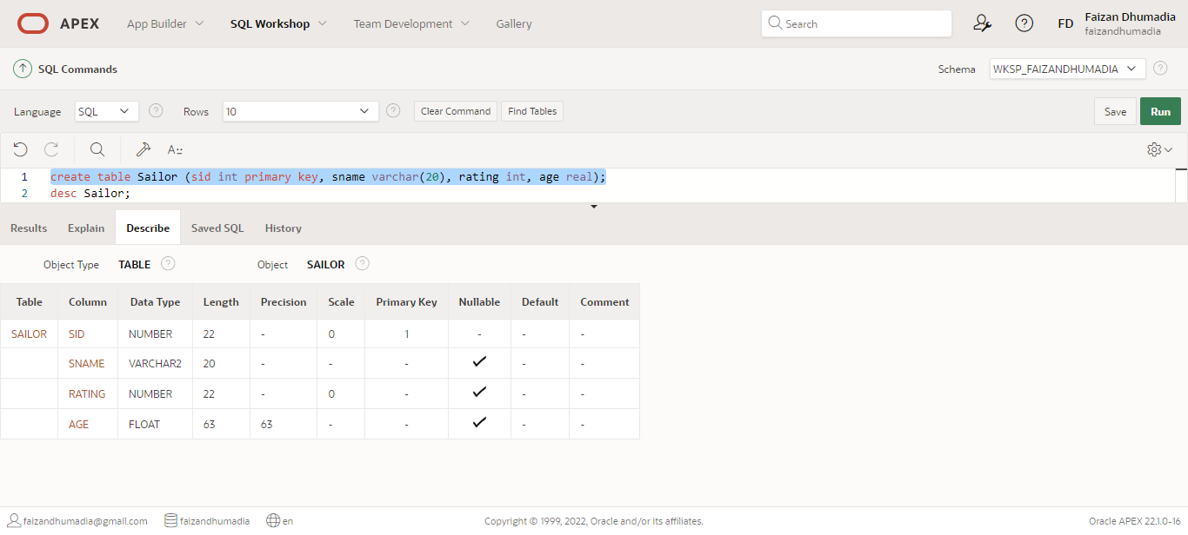

create table Boat ( bid int primary key, bname varchar(20), color varchar(20));

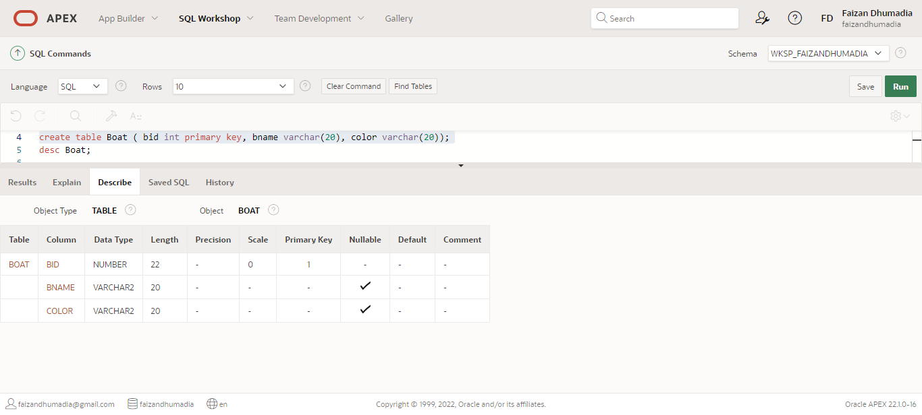

create table Reserves(sid int, bid int, day date, foreign key(sid) references Sailor(sid) on delete cascade,foreign key(bid) references Boat(bid) on delete cascade);

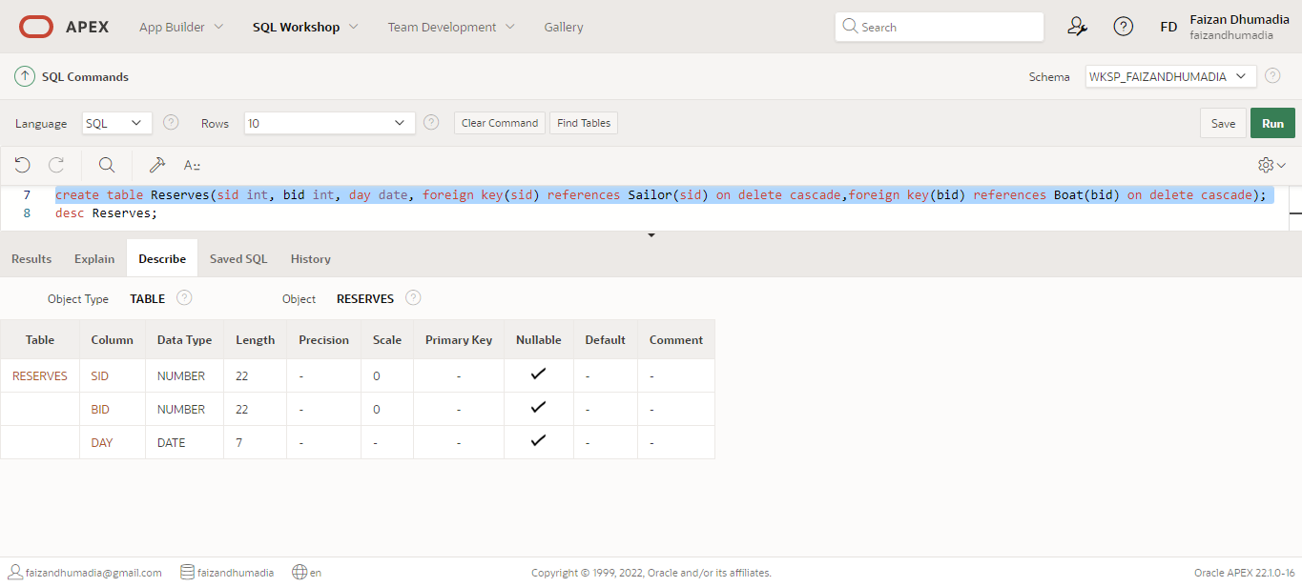

1. Inserting records in the tables

insert into Sailor values ( 22, 'Dustin', 7, 45.0 );

insert into Sailor values ( 29, 'Brutus', 1, 33.0 );

insert into Sailor values ( 31, 'Lubber', 8, 55.5 );

insert into Sailor values ( 32, 'Andy', 8,25.5 );

insert into Sailor values ( 58, 'Rusty', 10, 35.0 );

insert into Sailor values ( 64, 'Horatio', 7, 35.0 );

insert into Sailor values ( 71, 'Zorba', 10, 16.0 );

insert into Sailor values ( 74, 'Horatio', 9, 35.0 );

insert into Sailor values ( 85, 'Art', 3, 25.5 );

insert into Sailor values ( 95, 'Bob', 3, 63.5 );

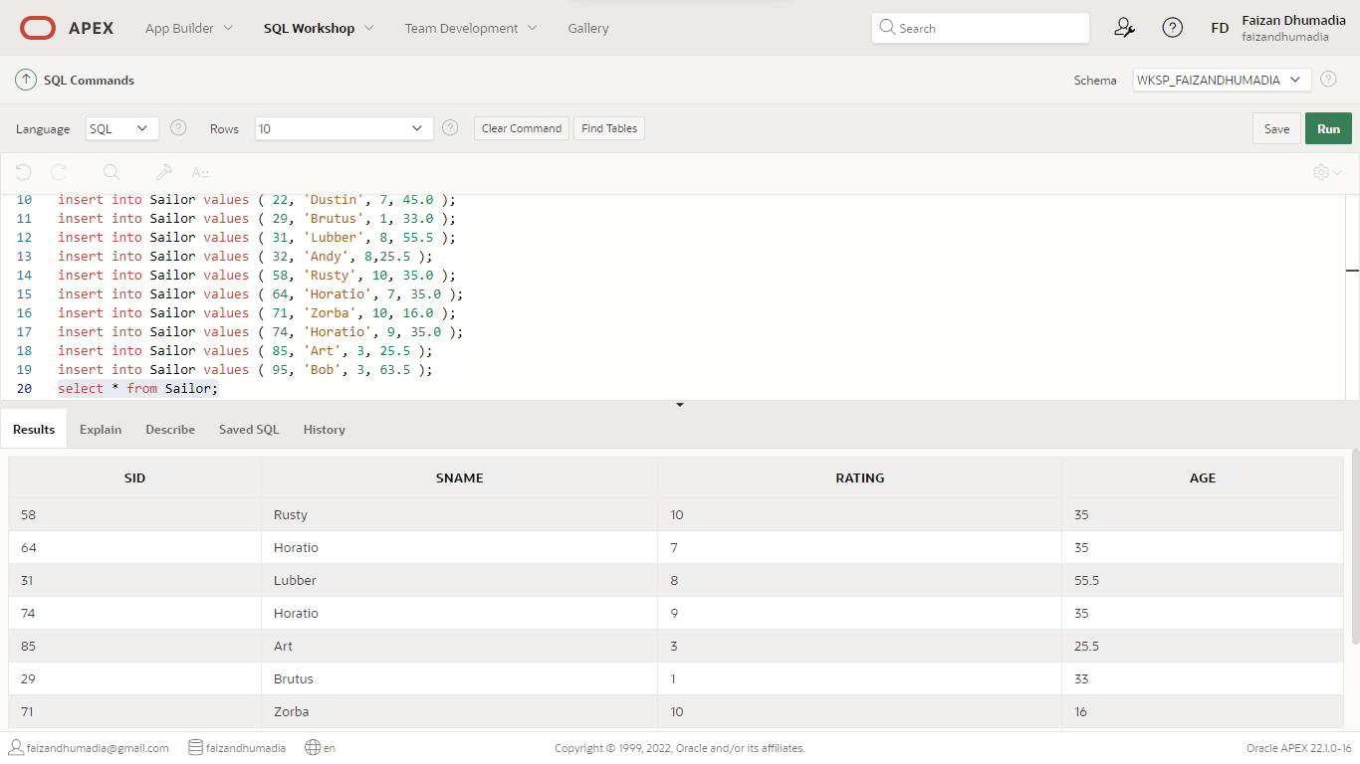

insert into Boat values(101,'Interlake', 'blue');

insert into Boat values(102,'Interlake', 'red');

insert into Boat values(103,'Clipper', 'green');

insert into Boat values(104,'Marine', 'red');

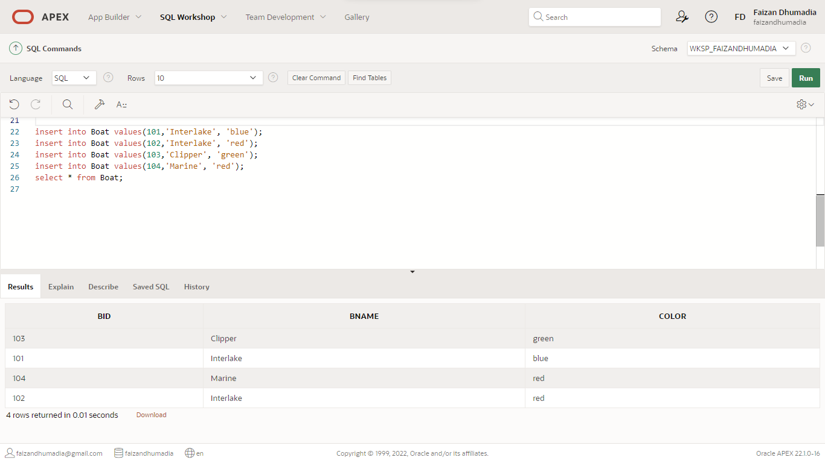

insert into Reserves values(22,101,'10/10/1998');

insert into Reserves values(22,102,'10/10/1998');

insert into Reserves values(22,103,'10/8/1998');

insert into Reserves values(22,104,'10/7/1998');

insert into Reserves values(31,102,'11/10/1998');

insert into Reserves values(31,103,'11/6/1998');

insert into Reserves values(31,104,'12/12/1998');

insert into Reserves values(64,101,'9/5/1998');

insert into Reserves values(64,102,'9/8/1998');

insert into Reserves values(74,103,'9/8/1998');

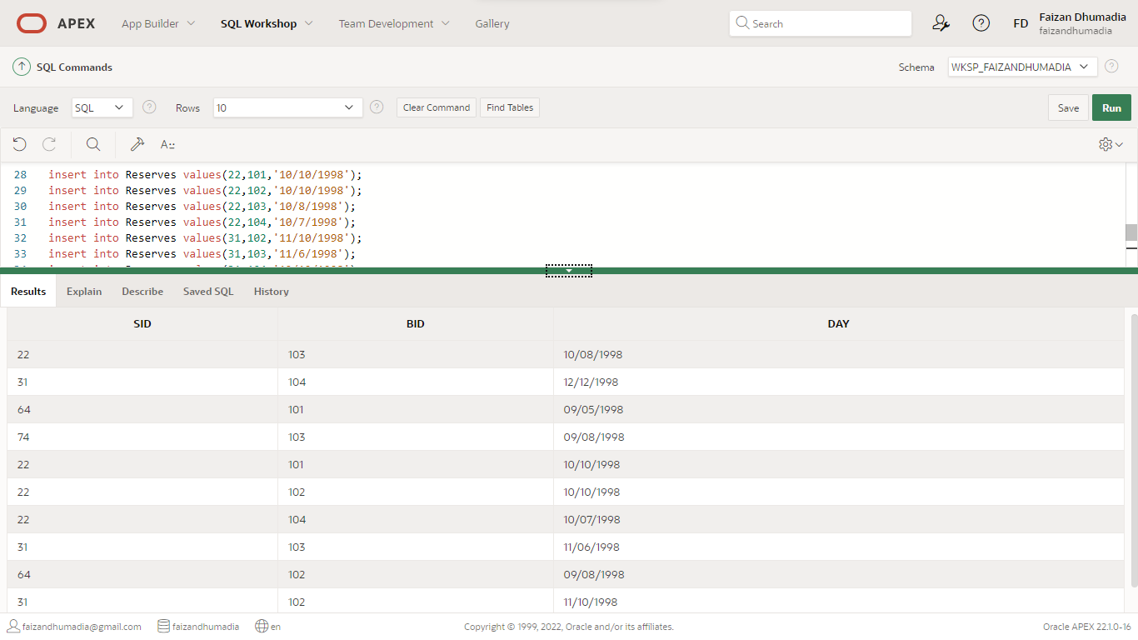

1. Find the age of the oldest sailor for each rating level. Print the rating level also

SELECT S.rating, MAX(S.age) FROM Sailor S GROUP BY S.rating;

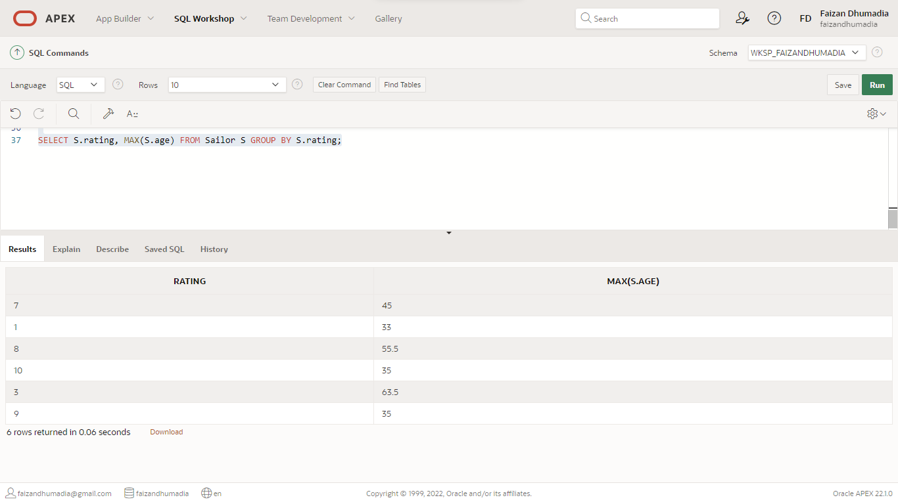

2. Find the average age of sailors for each rating level that has at least two sailors

SELECT S.rating, AVG(S.age) AS avg_age FROM Sailor S GROUP BY S.rating HAVING COUNT(*) > 1

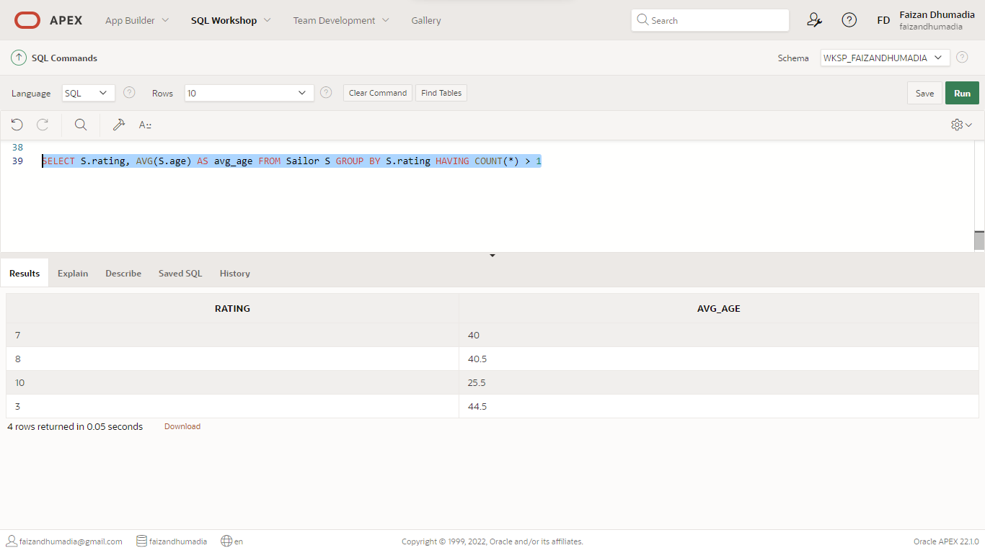

3. Find the number of reservations of each boat order by boat id.

SELECT B.bid, COUNT (*) AS NumberOfRes FROM Sailor S, Boat B, Reserves R WHERE S.sid=R.sid AND R.bid=B.bid GROUP BY B.bid ORDER BY B.bid;

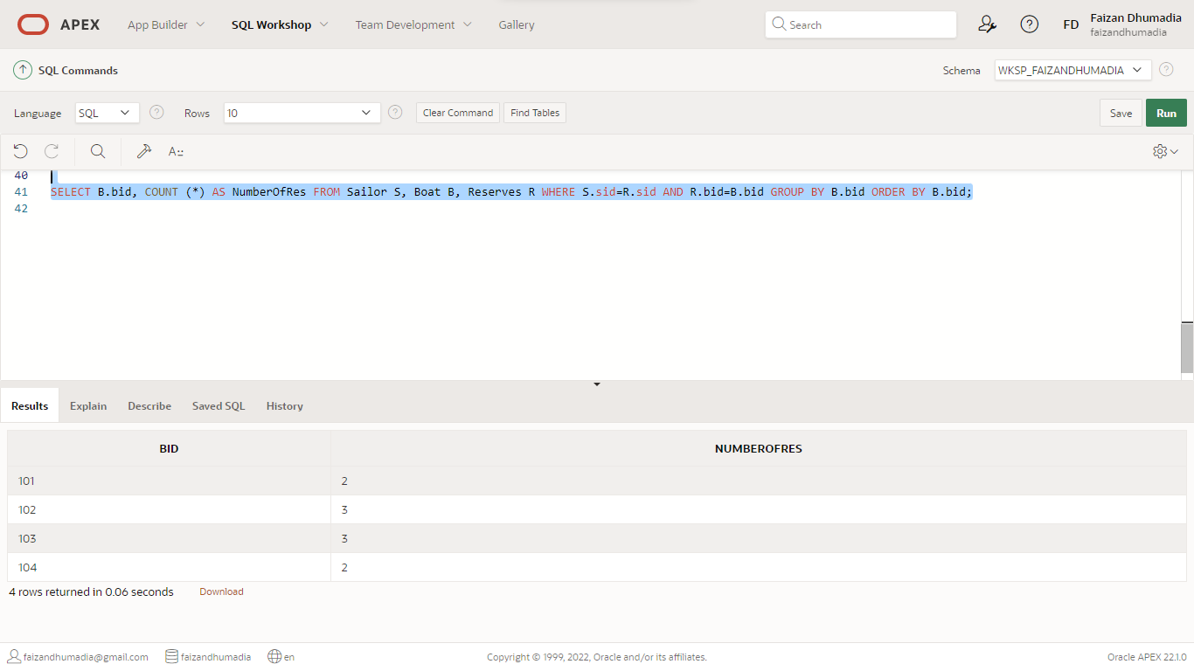

4. Find the age of the youngest sailor who is eligible to vote(i.e. at least 18 years old) for each rating level.

SELECT S.rating, MIN (S.age) AS minage FROM Sailor S WHERE S.age>= 18 GROUP BY S.rating;

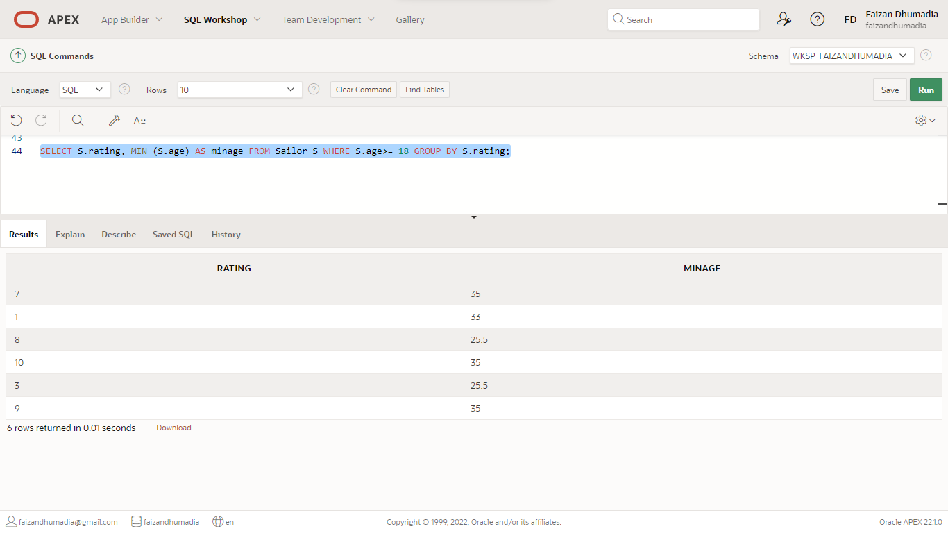

5. Create index on sid column for sailors table

CREATE INDEX index_SID ON Sailor(sid);

